SOLVED QUESTIONS OF NOVEMBER 2008 EXAMINATION

4 MARKS QS

1. WITH A BLOCK DIAGRAM SHOW HOW 8279 IS INTERFACED WITH 8086

8279 is a hardware approach to interfacing a matrix keyboard and a multiplexed display that scans and encodes up to a 64-key keyboard and controls up to a 16-digit numerical display.. It is a 40-pin device with two major segments keyboard and display. The keyboard segment can be connected to a 64 contact key matrix. The keyboard entries are debounced and stored in the internal FIFO memory; and an interrupt signal is generated with each entry. The display segment can provide a 16-character scanned display interfaces with devices like LED’s. This segment has 16*8 R/W memory, which can be used to read or write information for display purposes.

Programmable Keyboard/Display Interface - 8279
- A programmable keyboard and display interfacing chip.
  - Scans and encodes up to a 64-key keyboard.
  - Controls up to a 16-digit numerical display.
- Keyboard has a built-in FIFO 8 character buffer.
- The display is controlled from an internal 16x8 RAM that stores the coded display information.
Keyboards consist of a large matrix of keys, all of which are monitored by an on-board processor called the "keyboard encoder". The specific processor varies from keyboard-to-keyboard but they all basically do the same thing: Monitor which key(s) are being pressed/released and send the appropriate data to the host. This processor takes care of all the debouncing and buffers any data in its 16-byte buffer, if needed.
Motherboard contains a "keyboard controller" that is in charge of decoding all of the data received from the keyboard and informs software of what's going on.

Data Bus Buffer
FIFO/ Sensor RAM Status
Timing &
Control
Display
Register
Beyboard debounce
& Control
8 * 8 FIFO/ Sensor RAM
16 * 8 Display RAM

Display Addr Reg
Return
Scan Counter
I/O Control

8

SUVARNA

2.What are the applications of 8255?explain one in detail?

(can write any one of keyboard or display interface example also)

The 82C55A is a very powerful tool for interfacing peripheral equipment to the microcomputer system. It represents the optimum use of available pins and flexible enough to interface almost any I/O device without the need for additional external logic. Each peripheral device in a microcomputer system usually has a “service routine” associated with it. The routine manages the software interface between the device and the CPU. The functional definition of the 82C55A is programmed
by the I/O service routine and becomes an extension of the system software. By examining the I/O devices interface characteristics for both data transfer and timing, and matching this information to the examples and tables in the detailed operational description, a control word can easily be developed to initialize the 82C55A to exactly “fit” the application. Figures 18 through 24 present a few examples of typical applications of the 82C55A.

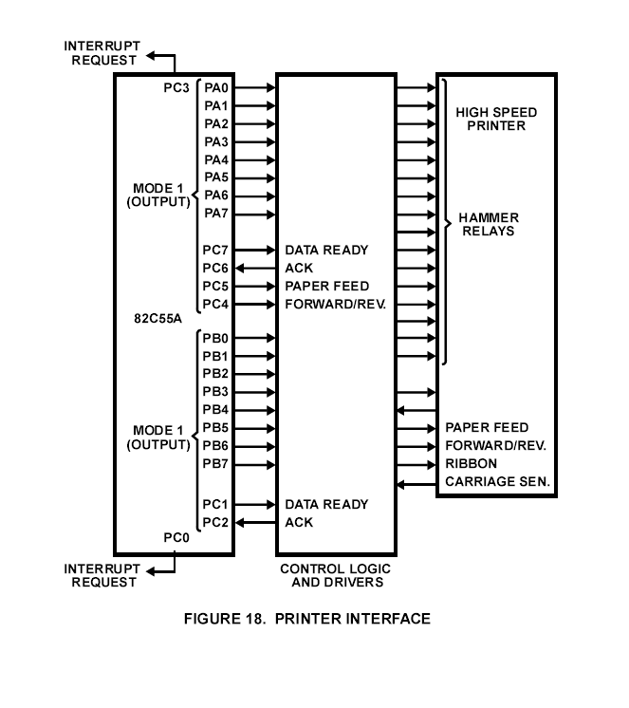

swetha raj

3. Explain the keyboard and display section of 8279?
8279 is a hardware approach to interfacing a matrix keyboard and a multiplexed display that scans and encodes upto a 64-key keyboard and controls upto a 16-digit numerical display. It is a 40-pin device with two major segments keyboard and display. The keyboard segment can be connected to a 64 contact key matrix.
Keyboard section consists of eight return lines RL0-RL7 that are connected to eight columns of a key board. It has two additional lines shift and CNTRL/STB (control/strobe). It also has a 8X8 FIFO RAM. The FIFO RAM consists of eight registers that can store eight keyboard entries; each is then read in the order of entries. The status logic keeps track of the number of entries and provides an IRQ (interrupt request) signal when FIFO RAM is not empty.
The display section has eight output lines divided into two groups A0-A3 and B0-B3. These lines are used as either as a group of eight lines or as two group of four in conjunction with scan lines for a multiplexed display. The output lines are connected to the anodes through driver transistor in case of common cathode 7 segment LED. The display can be blanked by BD line. The display section consists of 16X 8 display RAM. The MPU can read from or write into any of these registers.

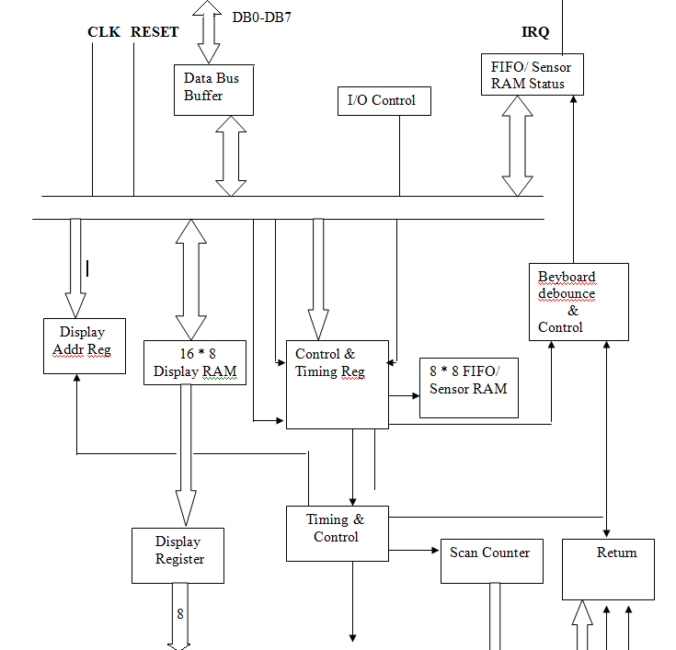

TEENU GEORGE

Q5 With examples explain addressing modes of 8086.

Addressing modes

Addressing modes indicate a way of locating data or operands. An addressing mode specifies how to calculate the effective memory address of an operand by using information held in registers and/or constants contained within a machine instruction. It describes the type of operands and the way they are accessed for execution of an instruction.

Direct (Displacement only) Addressing Mode
The most common addressing mode is the displacement-only (or direct) addressing mode. In this addressing mode, a 16-bit memory address (offset) is directly specified as part of the instruction..

Immediate addressing mode

In this type of addressing, immediate data is a part of instruction, and appears in the form of successive byte or bytes.
Eg: MOV AX,0005H

Here 0005H is an immediate data. The data can be 8 bit or 16 bit.

Register addressing mode
In register addressing mode, the data is stored in a register and it is referred using the particular register. All the registers, except IP can be used for this purpose.

Eg: MOV AX, BX

The Register Indirect Addressing Modes

Sometimes, the address of the memory location that contains data or operand is determined by in an indirect way using the offset registers. This mode of addressing mode is known as register indirect addressing mode. Here, the offset address of data is in either BX or SI or DI

Indexed Addressing Modes

In this mode of addressing, offset of the operand is stored in one of the index registers. DS and ES are the default segments for index registers SI and DI respectively

Based Indexed Plus Displacement Addressing Mode
These addressing modes are a slight modification of the base/indexed addressing modes with the addition of an eight bit or sixteen bit constant

Thomas charles

6 Explain minimum mode and maximum mode in 8086.

In a minimum mode 8086 system, the microprocessor 8086 is operated in minimum mode by strapping its MN/MX’ pin to logic 1. In this mode, all the control signals are given out by the microprocessor chip itself. There is a single microprocessor in the minimum mode system.

The following pin functions are for the minimum mode operation of 8086:

M/I/O’:
- This is a status line logically equivalent to S₂’ in the maximum mode.
- When it is low, it indicates that the CPU is having an I/O operation and when it is high, it indicates that the CPU is having a memory operation.

INTA’-Interrupt Acknowledge:
- This signal is used as read strobe for interrupt acknowledge cycles.
- When it goes low, the processor has accepted an interrupt.
- It invites the interrupting device to place the incoming vector on to the data line.

ALE-Address Latch Enable:
- This is an output signal.
- It indicates the availability of a valid address on the address/data line.
- It is connected to the latch enable input of latches.
- The signal is active is active high and is never tri-stated.

DT/R’-Data Transmit/Receive:
- This is used to determine the direction of data flow the trans-receivers.
- When the processor sends out data, the signal is high and when the processor is receiving data, the signal is low.
- It is tri-stated during the hold acknowledge.
- Logically, this signal is equivalent to S₁’ in maximum mode.

DEN’-Data Enable:
- This signal indicates the availability of valid data over the address/data lines.
- It is used to enable the trans-receivers to separate the data from the multiplexed address/data signal.
- This signal is tri-stated during the hold acknowledge cycle.

HOLD/HLDA-Hold/Hold Acknowledge:
- When the HOLD line goes high, it indicates to the processor that, another master is requesting the bus access.
- The processor, after receiving the HOLD request, issues the hold acknowledge signal on HLDA pin.
- When the processor finds that the HOLD line is low, it lowers the HLDA signal.
- HOLD is an asynchronous input and should be externally synchronized.

In a maximum mode 8086 system, the microprocessor 8086 is operated in maximum mode by strapping its MN/MX’ pin to logic 0. In this mode, another chip called bus controller derives the control signals using the status information from s₂’,s₁’ and s₀’. There may be more than one microprocessor in the maximum mode system system configuration.
Following are the signals applicable for the maximum mode operation of 8086:

S2’, S1’, S0’-Status Lines:
- These are status lines which reflect the type of operation, being carried out by the processor.
S₂’ | S₁’ | S₀’ | Indication
0  0  0  0  1  1  1  1 | 0  0  1  1  0  0  1  1 | 0  1  0  1  0  1  0  1 | Interrupt Acknowledge  Read I/O port  Write I/O port  Halt  Code Access  Read Memory  Write Memory  Passive

LOCK’:
- This is an active low signal.
- This pin indicates that other system bus masters will be prevented from gaining the system bus, while the LOCK’ signal is low.
- This pin is activated by the LOCK prefix instruction and remains active until the completion of the next instruction.

QS₁, QS₀-Queue Status:
- These lines give information about the status of the code pre-fetch queue.
- These are active during clock the cycle after which the queue operation is performed.
QS₁ | QS₀ | Indication
0  0  1  1 | 0  1  0  1 | No operation  First byte of opcode from the queue  Empty queue  Subsequent byte from the queue

RQ’/GT₀’, RQ’/GT₁’-Request/Grant:
- These pins are used by other local bus masters, in maximum mode to force the processor to release the local bus at the end of the processor’s current bus cycle.
- Each of the pin is bi-directional with RQ’/GT₀’ having higher priority than RQ’/GT₁’.

TITTA ANTONY

7 What is stack?explain the operation and uses of stack and the stackpointer?

ANSWER
The stack is temporary storage originally used to preserve return addresses when a subroutine is called. It is so convenient for temporary storage that it is used as the location of temporary or automatic variables for the use of subroutines. The top of the stack is at SS:SP(SP denotes the stack pointer), which is really the bottom, since the stack builds downwards, towards smaller offsets. It is very important that everything one pushes on the stack is later removed, so that the stack does not grow out of bounds and trash memory. Data may be overwritten on the stack, but it is not erased.

a) PUSH: Push to Stack
This instruction pushes the contents of the specified register/memory location onto the stack. The stack pointer is decremented by two, after each execution of the instruction. The actual current stack-top is always occupied by the previously pushed data. Hence, the push operation decrements SP by two and then stores the two byte contents of the operand onto the stack. The higher byte is pushed first and then the lower byte.

Eg: PUSH AX

PUSH DS
PUSH [5000H] ; Content of location 5000H and 5001H in DS are pushed onto stack.

b) POP: Pop from stack
POP AX, loads the low byte in the register, increments SP, loads the high byte, and increments SP again. I.e. it loads the specified register /Memory location with the contents of the memory location. The stack pointer is incremented by two. A PUSH followed by a POP restores the stack to its original state. The SP can be moved to BP, and then data can be accessed at SS:BP, since the default segment for BP is SS. This is how a subroutine accesses its automatic variables.

Eg: POP AX

POP DS

POP [5000H]

c) PUSHF: Push flags to stack
PUSHF pushes the flag register onto the satck; first upper byte and then the lower byte will be pushed onto stack. The SP will be decremented by two for each push operation.

d) POPF: Pop Flags from Stack
The POPF instruction loads the flag register completely from the word contents of the memory location currently addressed by SP and SS. The SP is incremented by two for each POP operation.

TRACY JOSEPH

8 Brief the salient features of protected virtual mode.

( protected mode in 80286)

ANSWER

Protected Mode
Protected mode has a number of new features designed to enhance multitasking and system stability, such as memory protection, and hardware support for virtual memory as well as task switching. It is sometimes abbreviated p-mode and also called Protected Virtual Address Mode.
In the 80386 and later 32-bit processors, a paging system was added and is part of protected mode.
The other main operational mode of 286 and later CPUs is real mode, a backwards compatibility mode that disables these features, designed to allow old software to run on newer chips. As a design specification, all x86 CPUs, except the 80376, start in real mode at boot time to ensure backwards compatibility with legacy operating systems. They must be switched into protected mode by a program before any protected mode features are available. In modern computers, this switch is usually one of the very first tasks performed by the operating system at boot time.
While software-mediated multitasking is certainly possible on systems running in real mode, the memory protection features of protected mode prevent an erroneous program from damaging the memory "owned" by another task or by the operating system kernel. Protected mode also has hardware support for interrupting a running program and shifting execution context to another, enabling pre-emptive multitasking.

TREASA CHERIAN

9.Explain the memory management in 80386

The physical memory of an 80386 system is organized as a sequence of 8-bit bytes. Each byte is assigned a unique address that ranges from zero to a maximum of 2^(32) -1 (4 gigabytes). The 80386 transforms logical addresses (i.e., addresses as viewed by programmers) into physical address (i.e., actual addresses in physical memory) in two steps:
- Segment translation, in which a logical address (consisting of a segment selector and segment offset) are converted to a linear address.
- Page translation, in which a linear address is converted to a physical address.
These translations are performed in a way that is not visible to applications programmers.

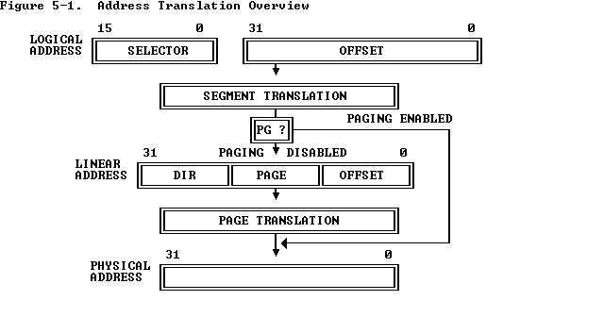

To perform this translation, the processor uses the following data structures:
- Descriptors : The segment descriptor provides the processor with the data it needs to map a logical address into a linear address
- Descriptor tables : The descriptor table defines all the segments used in the 80386 when it operates in the protected mode
Selectors The selector portion of a logical address identifies a descriptor by specifying a descriptor table and indexing a descriptor within that table
- Segment Registers :stores the base addresses of corresponding segments

TS RADHIKA

Q10. Briefly explain branch prediction in Pentium processor. (4 marks)

A. The pipelined approach to program execution fails each time a branch instruction is encountered, because the buffers will have to be cleared again as the required instructions are in another location. The Pentium processor has been designed with a branch prediction system to reduce the number of times the cache needs to be cleared.

Branch prediction involves checking previously used branch instructions (Stored in a 256 entry branch target buffer (BTB)) with the branch instruction fetched and determining if the same branching will take place. If the processor decides that the execution will go to the previously mentioned branch, it will put those instructions for pipelining. As execution continues, if the branch prediction was correct, time will have been saved from flushing the cache. If the prediction is wrong, then the cache will have to be emptied as usual and a small delay in execution occurs.

Though there is a small chance that the cache has to be cleared again, processing time is saved by about 20%.

Given below is a figure to represent how branch prediction takes place.

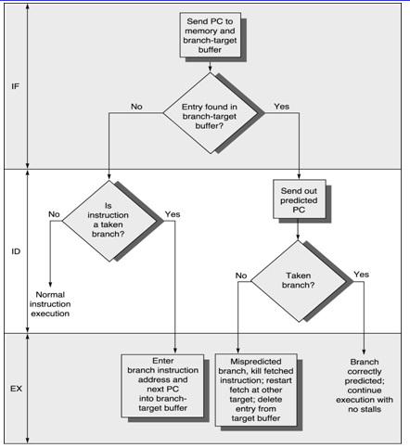

XAVIER VARICAT

12 marks qs follows

Q.Write the format for the commands in 8279
a.Read FIFO senor mem
b.write
swetha raj

Q Draw and explain the internal architecture and working of 8251?

8251A is a programmable peripheral designed for synchronous /asynchronous serial data communication, packaged in a 28-pin DIP. It includes five sections:
      - Read/Write Control Logic
      - Modem Control
      - Data Bus buffer
      - Transmitter
5) Receiver
Read/Write Control logic
This section includes a control logic, six input signals, and three buffer registers: Data register, control register and status register. The control logic interfaces the chip with MPU, determines the functions of the chip according to the control word in the control register and monitors the data flow.

Input signals
- CS – Chip Select: When this signal goes low, the 8251A is selected by the MPU for communication.
- C/D – Control/Data: When this signal is high, the control or status register is addressed; when it is low, data buffer is addressed. The control register and status register are differentiated by WR and RD signals.
- WR: When this signal is low, the MPU either writes in the control register or sends output to the data buffer
- RD: When this signal goes low, the MPU either reads a status from the status register or accepts data from data buffer.
- RESET: A high on this signal reset 8252A and forces it into the idle mode.
- CLK: This is the clock input, usually connected to the system clock for communication with the microprocessor.

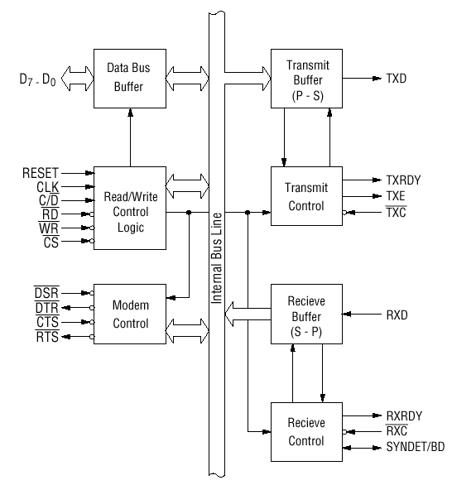
Control Register
The 16-bit register for a control word consist of two independent bytes. : the first byte is called mode word and the second byte is called the command word. The mode word specifies the general characteristics of operation such as baud, parity, number of bits etc. But the command word enables the data transmission and reception. The register can be accessed as an output port when the Control/Data pin is high.
Status register
This input register checks the ready status of the peripheral. The status word in the status register provides the information concerning register status and transmission errors.
Data buffer
This bidirectional register can be used as an input and output port when the C/D is low.
Transmitter section
The transmitter accepts parallel data from MPU and converts them into serial data. It has two registers:
- buffer register to hold eight bits
- output register to convert eight bits into a stream of serial bits.

Transmit control
Output Register
Transmitter Buffer

Transmitter Buffer

The MPU writes a byte in the buffer register, whenever the output register is empty; the contents of buffer register are transferred to output register. And transmit the data on the TxD pin with appropriate framing bits. Three output and one input signals are associated with this transmitter section.
TxD: This is an output signal to transmit the data to peripherals
TxC: An in put signal controls the rate of transmission.
TxRDY: An output signal, indicate the buffer register is empty and the USART is ready to accept the next data byte.
TxE: An output signal to indicate the output register is empty and the USART is ready to accept the next data byte.

Receiver Section
Receiver section accepts serial data on the RxD pin and converts them to parallel data. This section has two registers:

- the receiver input register
- The buffer register.
RxD
Receive Buffer
Receive control
Input Register

RxRDY
RxC
When the RxD goes low, the control logic assumes it is a start bit, waits for half bit time, and samples the line again. If the line is still low, the input register accepts the following data, and loads it into buffer register at the rate determined by the receiver clock.
RxRDY- receiver Ready: This is an output signal. It goes high when the USART has a character in the buffer register and is ready to transfer it to the MPU.
RxD- Receive data: Bits are received serially on this line and converted into a parallel byte in the receiver input register.
RxC- Receiver clock: This is clock signal that controls the rate at which bits are received by the USART.
Modem control
It is used to provide communication through telephone lines using modem.
The different lines are:

DSR – Data set ready
Check if data is ready to be sent through modem.

DTR- Data terminal ready
Check if device is ready to accept data or not through moadem.

RTS- Request to sent
Device is requesting 8251 to sent the data.

CTS- Clear to send

TEENU GEORGE

Q With examples explain addressing modes of 8086.

Addressing modes

Addressing modes indicate a way of locating data or operands. An addressing mode specifies how to calculate the effective memory address of an operand by using information held in registers and/or constants contained within a machine instruction. It describes the type of operands and the way they are accessed for execution of an instruction.

1) Direct (Displacement only) Addressing Mode
The most common addressing mode is the displacement-only (or direct) addressing mode. In this addressing mode, a 16-bit memory address (offset) is directly specified as part of the instruction..

The instruction MOV AL, DS:[8088H] loads the AL register with a copy of the byte at memory location 8088H. Likewise, the instruction MOV [1234H], DS:DL stores the value in the DL register to memory location 1234H.

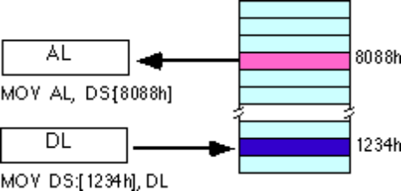
The displacement-only addressing mode is perfect for accessing simple variables.
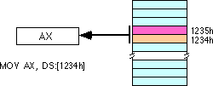

By default, all displacement-only values provide offsets into the data segment. If we want to provide an offset into a different segment, we must use a segment override prefix before the address. For example, to access location 1234H in the extra segment (ES) we would use an instruction of the form MOV AX, ES:[1234H]. Likewise, to access this location in the code segment we would use the instruction MOV AX, CS:[1234H]. The DS: prefix in the previous examples is not a segment override.

Immediate addressing mode

In this type of addressing, immediate data is a part of instruction, and appears in the form of successive byte or bytes.
Eg: MOV AX,0005H

Here 0005H is an immediate data. The data can be 8 bit or 16 bit.

Register addressing mode
In register addressing mode, the data is stored in a register and it is referred using the particular register. All the registers, except IP can be used for this purpose.

Eg: MOV AX, BX

4) The Register Indirect Addressing Modes

Sometimes, the address of the memory location that contains data or operand is determined by in an indirect way using the offset registers. This mode of addressing mode is known as register indirect addressing mode. Here, the offset address of data is in either BX or SI or DI

There are four forms of this addressing mode on the 8086, best demonstrated by the following instructions:
mov al, [bx]
mov al, [bp]
mov al, [si]
mov al, [di]

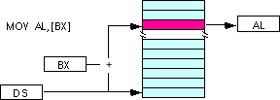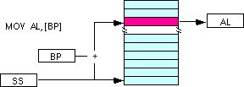
Note: the [si] and [di] addressing modes work exactly the same way, just substitute si and di for bx above.

Indexed Addressing Modes

In this mode of addressing, offset of the operand is stored in one of the index registers. DS and ES are the default segments for index registers SI and DI respectively.
The indexed addressing modes use the following syntax:

mov al, disp[bx]
mov al, disp[bp]
mov al, disp[si]
mov al, disp[di]

If bx contains 1000h, then the instruction mov cl,20h[bx] will load cl from memory location ds:1020h. Likewise, if bp contains 2020h, mov dh,1000h[bp] will load dh from location ss:3020.
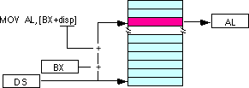

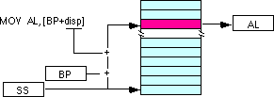

We may substitute si or di in the figure above to obtain the [si+disp] and [di+disp] addressing modes.
6) Register Relative

In this addressing mode, the data is available at an effective address formed by adding an 8-bit or 16-bit displacement with the content of any one of the registers BX, BP, SI and DI. in the default segment.
Eg: MOV AX, 50H[BX]

The effective address is given as 10H * DS + 50H + [BX]
7) Based Indexed Addressing Modes

The based indexed addressing modes are simply combinations of the register indirect addressing modes. The effective address is calculated by adding the content of base register (bx or bp) to the content of an index register (si or di).
Eg: MOV AX, [BX] [SI]

Effective address is computed as 10H * DS + [BX] + [SI]
The allowable forms for these addressing modes are

mov al, [bx][si]
mov al, [bx][di]
mov al, [bp][si]
mov al, [bp][di]

Suppose that bx contains 1000h and si contains 880h. Then the instruction
mov al,[bx][si]

would load al from location DS:1880h. Likewise, if bp contains 1598h and di contains 1004, mov ax,[bp+di] will load the 16 bits in ax from locations SS:259C and SS:259D.
The addressing modes that do not involve bp use the data segment by default. Those that have bp as an operand use the stack segment by default.
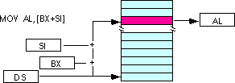
By substituting di in the figure above, we can obtain the [bx+di] addressing mode.
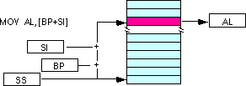

We substitute di in the figure above for the [bp+di] addressing mode.

8) Based Indexed Plus Displacement Addressing Mode
These addressing modes are a slight modification of the base/indexed addressing modes with the addition of an eight bit or sixteen bit constant. The following are some examples of these addressing modes:

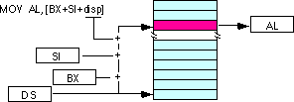
mov al, disp[bx][si]
mov al, disp[bx+di]
mov al, [bp+si+disp]
mov al, [bp][di][disp]

di may be substituted in the figure above to produce the [bx+di+disp] addressing mode.

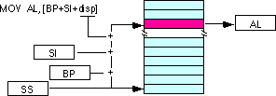

Suppose bp contains 1000h, bx contains 2000h, si contains 120h, and di contains 5. Then mov al,10h[bx+si] loads al from address DS:2130; mov ch,125h[bp+di] loads ch from location SS:112A; and mov bx,cs:2[bx][di] loads bx from location CS:2007.

Control flow instruction addressing modes

- Intersegment mode
If the location to which control is to be transferred lies in a different segment other than the current one, the mode is called intersegment mode.

- Intrasegment mode

If the destination location lies in the same segment, the mode is called intrasegment mode.

Intrasegment direct

Intrasegment
Modes for control
Intrasegment Indirect
Transfer instructions Intersegment Direct
Inter Intersegment

Intersegment Direct Four types:

- Intrasegment Direct Mode

In this mode, the address to which the control is to be transferred lies in the same segment in which the control transfer instruction lies and appears directly in the instruction as an immediate displacement value. In this mode, the displacement is computed relative to the content of the instruction pointer IP.
The effective address to which control is transferred is given by the sum of 8 or 16 bit displacement and current content of IP. In case of jump instruction, if the signed displacement (d) is of 8 bits (-128<d<+128), we term it as short jump and if it is of 16 bits, it is termed as long jump.

- Intra segment Direct Mode
In this mode the displacement to which the control is to be transferred is in the same segment in which the control transfer instruction lies, but it is passed to the instruction indirectly. Here, the branch instruction is found as the content of register or a memory location. This addressing mode may be used in unconditional branch instructions.

- Intersegment Direct Mode

In this mode, the address to which the control is to be transferred is in a different segment. The addressing mode provides a means of branching from one code segment to another code segment. Here the CS and IP of the destination address are specified directly in the instruction.

- Intersegment Indirect Mode

In this mode, the address to which the control is to be transferred is in a different segment and it is passed to the instruction indirectly, i.e contents of a memory block containing four bytes, i.e IP(LSB), IP(MSB), CS(LSB) and CS(MSB).The starting address of the memory block may be referred using any of the addressing mode, except immediate..

TITTA ANTONY

Q Draw and explain the timming diagram for memory read operation.

ANSWER
All the processor bus cycles consist of at least four clock cycles. these are reffered to as T1,T2,T3 andT4.The adress is transmitted by the processor during T1.During T2, the bus is tristated for changing the direction ofbus for the folowingdata read cycle.The data transfer takes place during T3and T4.In case, an adressed device shows "not ready" status the wait states Tw are inserted betweenT3 and T4.The status lines S0,s1 and S2 are used to indicate the type of operation.For memory read, S2=1,S1=1 and S3=0.Status bits S3 to S7 are multiplexed with higher order address bits and the BHE signal.Adress is valid during T1 while the status bits S3 toS7 are valid during T2 to T4.
The timing diagram for memory read operation is given in fig1.8, page-17(A K RAY).
TRACY JOSEPH

QHow is the exception processing done in 80286?Explain in detail by mentioning various possible exceptions?

In the real address mode, the 80286 exception mechanism is similar tp 8086 except a few more exceptions such as “invalid opcode exception”,is included in 80286.External interrupts such as the maskable INTR and non maskable NMI interrupts in the 80286 are received in the real addressed mode by using interrupt vector table with 256 entries similar to 8086.

In the protected mode , 80286 detects exceptions essential to its protection model and its support for multitasking and virtual memory.Some examples of non real mode exceptions include ‘exceptions for code’, ‘data not present’
and ‘privilage violation’.

Function | Interrupt no | Related instruction | Does return address point to intstruction causing exception?
Divide error exception | 0 | Div,div | Yes
Single step interrupt | 1 | A11
NMI | 2 | INT 2 orNMI pin
Breakpoint interrupt | 3 | INT 3
INTO detected overflow | 4 | INT 0
BOUND range exceeded exception | 5 | BOUND | Yes
Invalid opcode | 6 | ANY UNDEFINED OPCODE | Yes
Processor extention not available | 7 | ESC or WAIT | Yes
Intel reserved,do not use | 8-15
Processor extension error interrupt | 16 | ESC OR WAIT | YES
User defined | 32-255

TS RADHIKA

Q. Using neat figures, explain various features of how various features of the Pentium processor speed up program execution. (10 marks)

A. Some of the essential features of its architecture are:
- Pentium processor uses Superscalar architecture and hence can issue multiple instructions per cycle.
- The Pentium processor fetches the branch target instruction before it executes the branch instruction.
- On chip FPU.
- Complex Instruction Set Computer (CISC) architecture with Reduced Instruction Set Computer (RISC) performance.
- The Pentium processor has two separate 8-kilobyte (KB) caches on chip, one for instructions and one for data. It allows the Pentium processor to fetch data and instructions from the cache simultaneously.
- 64-Bit Bus, Upward code compatibility.

Superscalar architecture:
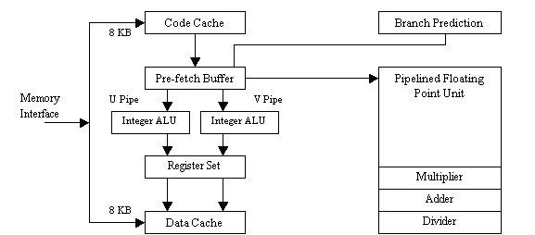
The Pentium's basic integer pipeline is five stages long, with the stages broken down as follows:
- Pre-fetch/Fetch: Instructions are fetched from the instruction cache and aligned in pre-fetch buffers for decoding.
- Decode1: Instructions are decoded into the Pentium's internal instruction format that is control word. Branch prediction also takes place at this stage.
- Decode2: Decodes it for final execution and also generate the address for data reference.
- Execute: The integer hardware executes the instruction.
- Write-back: The results of the computation are written back to the register file.

Floating Point Unit:
There are 8 general-purpose 80-bit Floating point registers. Floating point unit has 8 stages of pipelining. First five are similar to integer unit. Since the possibility of error is more in Floating Point unit (FPU) than in integer unit, additional error checking stage is there in FPU. The different segments of the FPU are:
- FRD - Floating Point Rounding
- FDD - Floating Point Division
- FADD - Floating Point Addition
- FEXP - Floating Point Exponent
- FAND - Floating Point And
- FMUL - Floating Point Multiply
The FPU comes with a set of new instructions for handling floating point data:
- FSIN : TO COMPUTE SIN(θ)
- FCOS : TO COMPUTE COS(θ)
- FSINCOS : TO COMPUTE SINE AND COSINE
- FPTAN : TO COMPUTE TAN(θ)
- FPATAN : TO COMPUTE ARCTAN(X)
- F2XMI : TO COMPUTE (2X-1)
- FYL2X : TO COMPUTE Y*LOG2X
- FYL2XP : TO COMPUTE Y*LOG2(X+1)
As said earlier errors can happen during floating point execution and as a result of these errors, exceptions occur and the corresponding ISR is executed. There are 5 possible floating point exceptions:
- Divide by zero
- Overflow
- Underflow
- Denormal operand
- Invalid operation.

Branch prediction:
The Pentium processor has been designed with a branch prediction system to reduce the number of times the cache needs to be cleared.

Branch prediction involves checking previously used branch instructions (Stored in a 256 entry branch target buffer (BTB)) with the branch instruction fetched and determining if the same branching will take place. If the processor decides that the execution will go to the previously mentioned branch, it will put those instructions for pipelining. As execution continues, if the branch prediction was correct, time will have been saved from flushing the cache. If the prediction is wrong, then the cache will have to be emptied as usual and a small delay in execution occurs.

Though there is a small chance that the cache has to be cleared again, processing time is saved by about 20%.
XAVIER

